**VPC project used in production**

**VPC**

Imagine you want to set up a private, secure, and isolated area in the cloud where you can run your applications and store your data. This is where a VPC comes into play.

A VPC is a virtual network that you create in the cloud. It allows you to have your own private section of the internet, just like having your own network within a larger network. Within this VPC, you can create and manage various resources, such as servers, databases, and storage.

Think of it as having your own little "internet" within the bigger internet. This virtual network is completely isolated from other users' networks, so your data and applications are secure and protected.

Just like a physical network, a VPC has its own set of rules and configurations. You can define the IP address range for your VPC and create smaller subnetworks within it called subnets. These subnets help you organize your resources and control how they communicate with each other.

To connect your VPC to the internet or other networks, you can set up gateways or routers. These act as entry and exit points for traffic going in and out of your VPC. You can control the flow of traffic and set up security measures to protect your resources from unauthorized access.

With a VPC, you have control over your network environment. You can define access rules, set up firewalls, and configure security groups to regulate who can access your resources and how they can communicate.

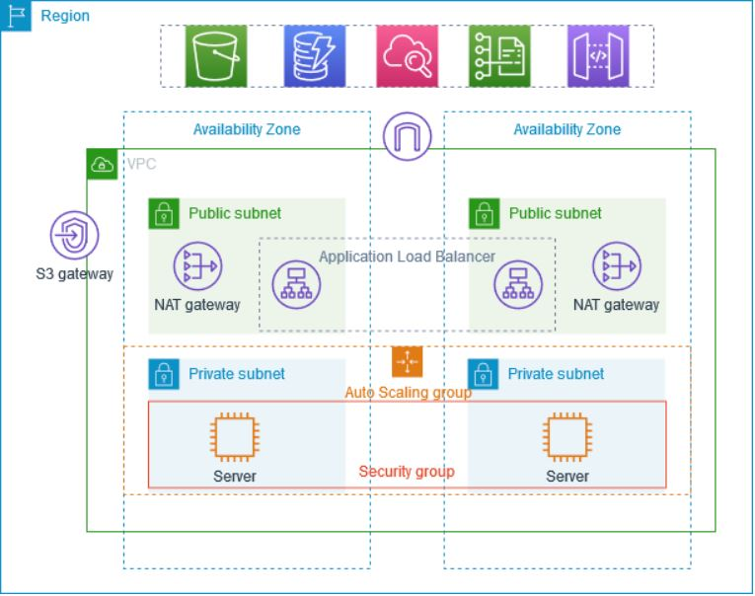

**Subnets**

A subnet is a range of IP addresses in your VPC. A subnet must reside in a single Availability Zone. After you add subnets, you can deploy AWS resources in your VPC.

You can assign IP addresses, both IPv4 and IPv6, to your VPCs and subnets. You can also bring your public IPv4 and IPv6 GUA addresses to AWS and allocate them to resources in your VPC, such as EC2 instances, NAT gateways, and Network Load Balancers.

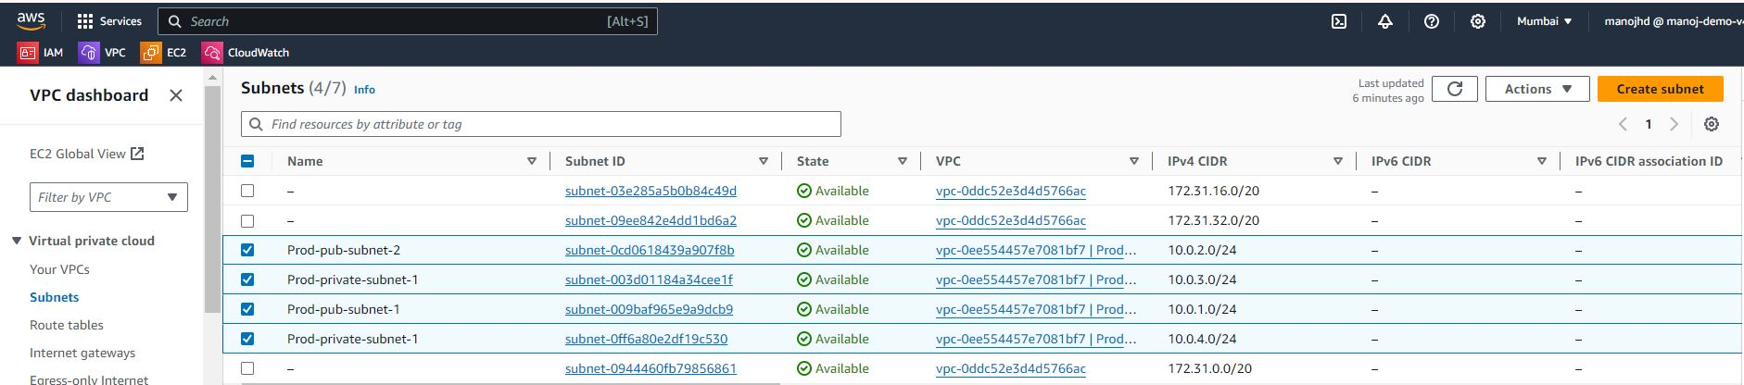

**Route table**

Use route tables to determine where network traffic from your subnet or gateway is directed.

**Private route table**

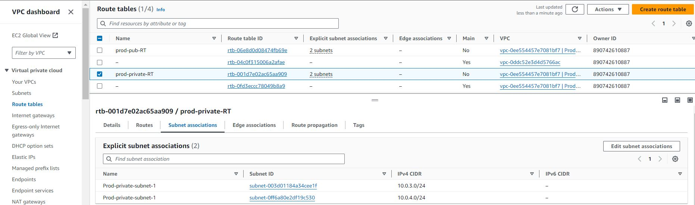

**Public route table**

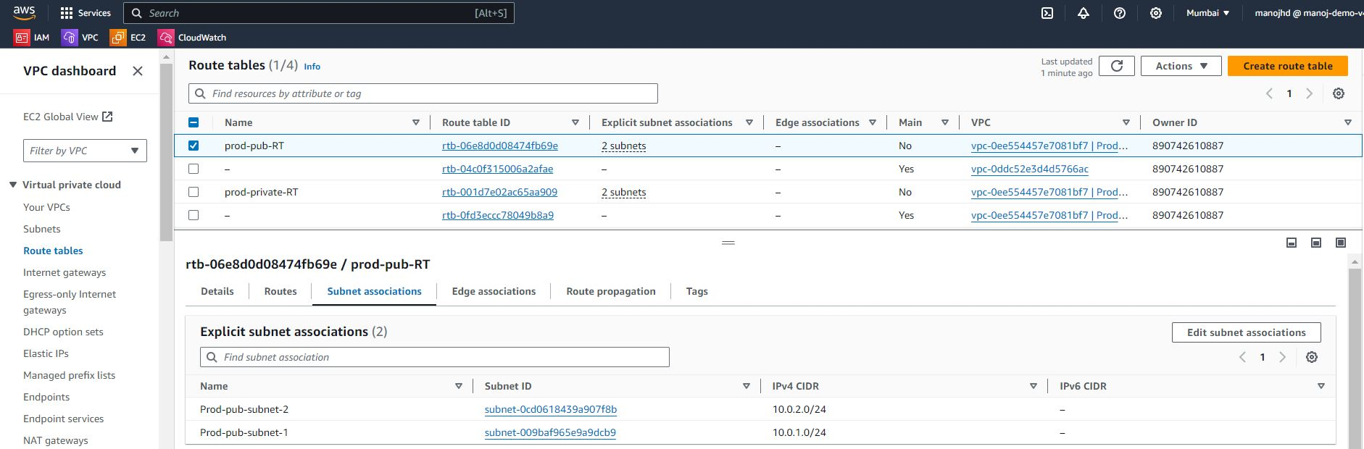

**Internet Gateway**

InternetGateway has been created and attached to VPC and route table.

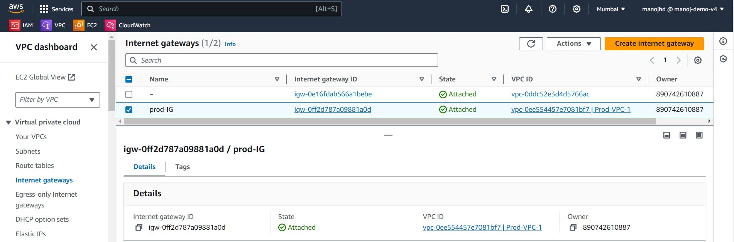

**Load balancer**

Load balancer has been created inside the VPC and attached target group where instances has attached.

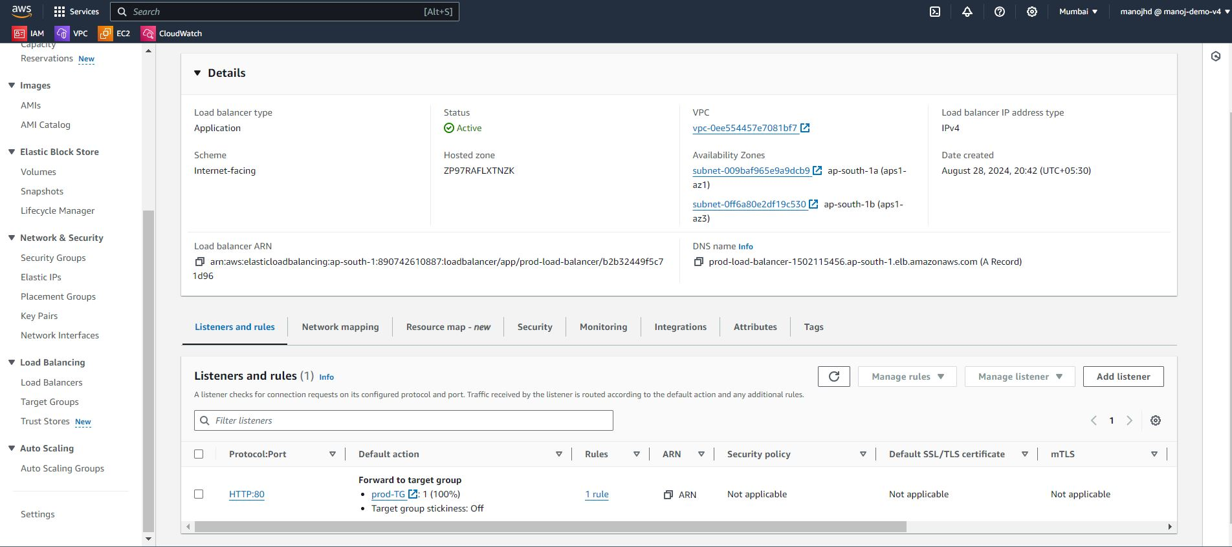

**Target group**

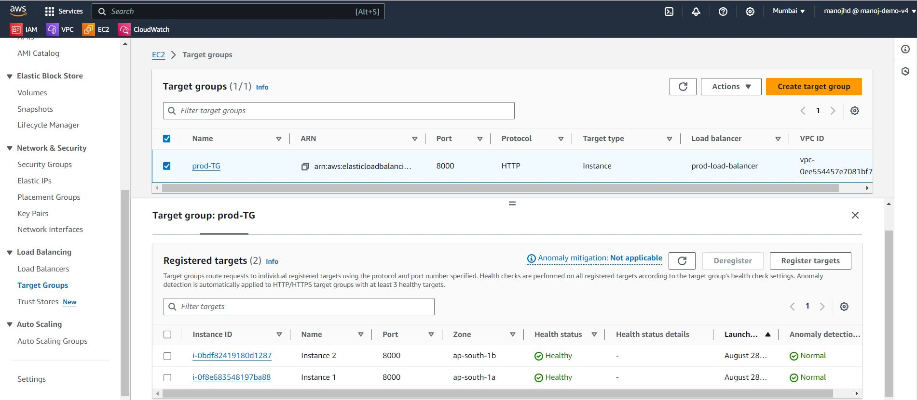

**Auto scaling group**

Created ASG to scale up or scale down the number of instances based on the traffic.

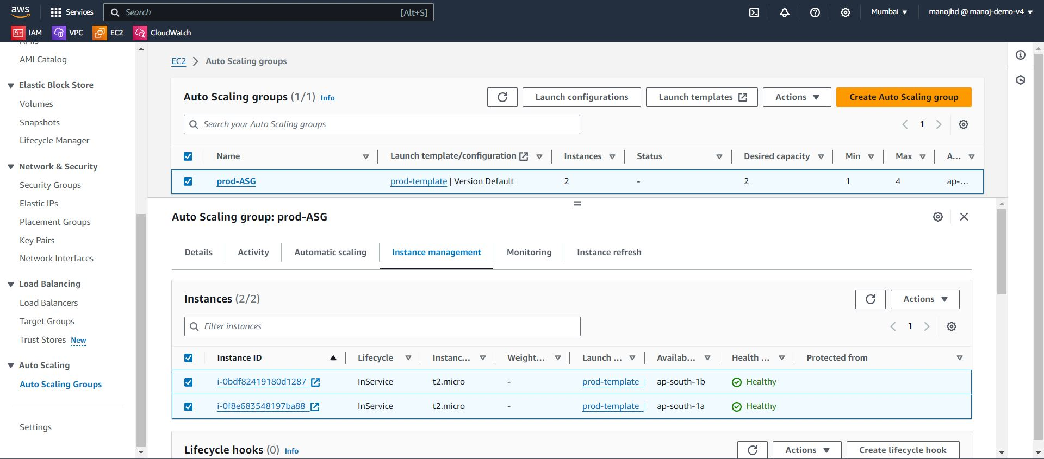

**NAT gateway**

NAT gateway which is created inside the public subnet and assigned static IP address and connect to private subnets through private route table, which hides the private IP address of private instance and send to traffic to collect necessary information to hide and secure the IP address of private instance.

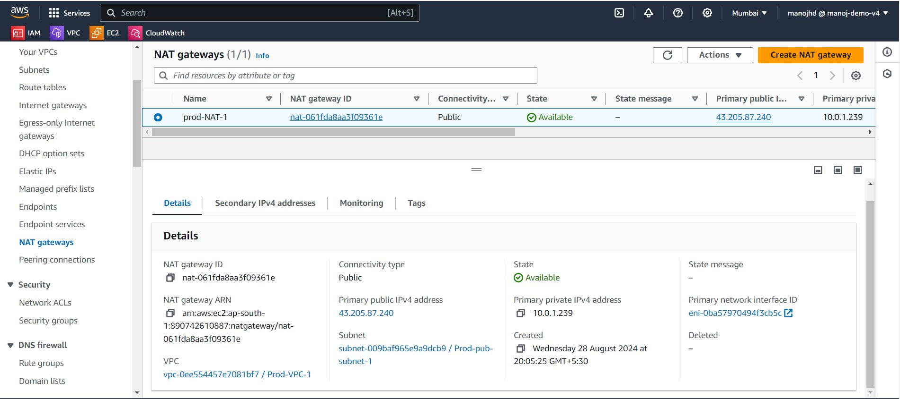

**Network ACL**

NACL work on subnet level, which allow or deny the traffic to instance on subnet level.

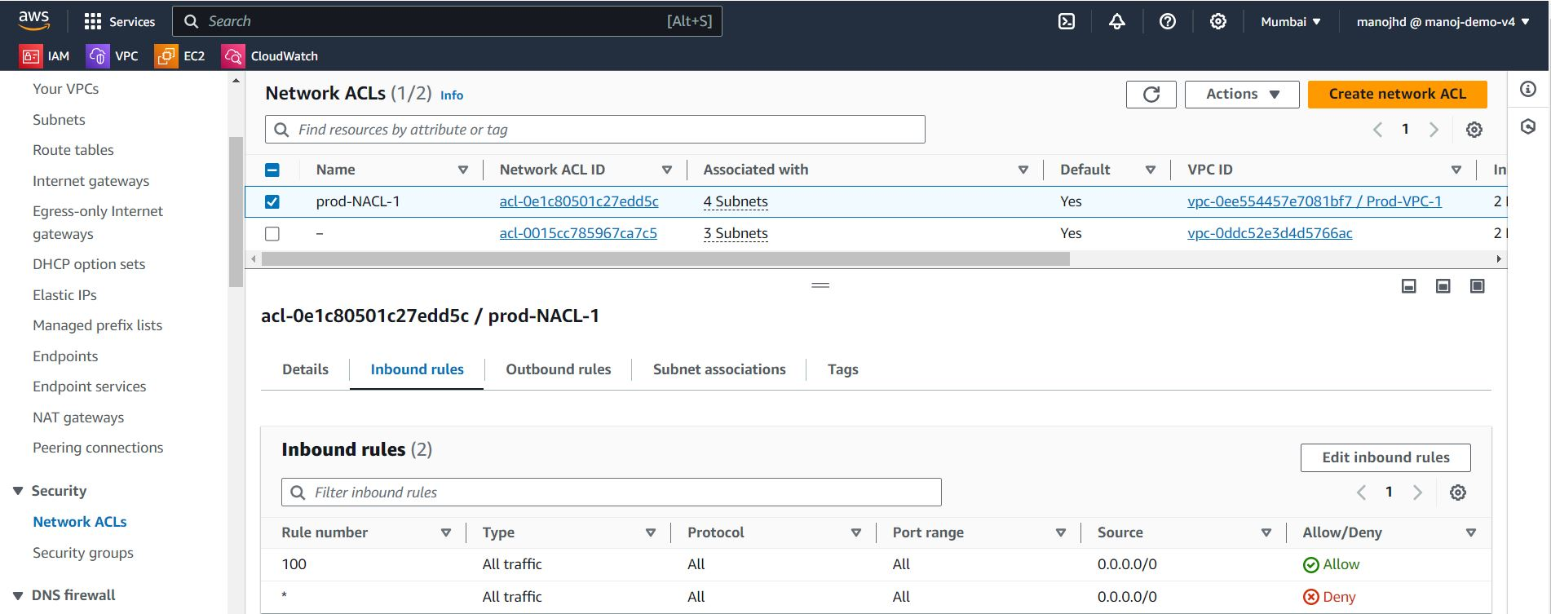

**Result**

Traffic flowing on both instance 1 and Instance 2 based on number of requests received.

